**One File => WP_Macro_OneFile_Template.xlsm**

**Description:**

This spreadsheet is created to process **one** Client input file (.XLS or .CSV) that contains both demographics and deposit data.

Macros will copy data from the input file, format, and create three Comma-delimited files in Alegeus Specified Format (.MBI).

**Note: Each Client are expected to supply an Input file in consistent format**

Macro File => WP_Macro_OneFile_Template.xlsm

Current Location => S:\Work (Public)\LDF\WageParity-2022\_MACROS\

**WORKSHEETS:**

**MAIN** (highlighted Green)

This is the main worksheet and where the process starts.

**Instructions**

This will contain basic instructions on how to use the Spreadsheet

**Lookup** (highlighted Tab in Blue)

This contains data used to default values in the Feed Templates

**Expected Data**

This contains the Column headers and corresponding data that is expected for each Client

Warning: Sometimes the column headers are same but data can be different. For example: In the input file, the Client deducts the fee from Deposit Amount and other times not. This can yield different deposit amounts.

**Client_Input_File**

This Template contains data copied over from the Client Input File.

Button ‘Get Data’ copies data in original format from the Client files into this template.

**Demo_Template**

This Template pulls and formats the demographics data from the Client file

Button ‘Create Demo File’ creates the MBI file (Record ID “IH”)

**Enroll_Template**

This Template pulls and formats the Enrollment data from the Client file

Button ‘Create Enroll File’ creates the MBI file (Record ID “IC”)

**Deposits_Template**

This Template pulls and formats the Deposits data from the Client file

Button ‘Create Deposits File’ creates the MBI file (Record ID “IH”)

**INSTRUCTIONS TO PROCESS A NORMAL FILE**

**Steps:**

1. On worksheet ‘MAIN’ (highlighted Green tab), select ‘Employee ID’ => ‘**BENABJHOM – ABJ Home Care Agency’**

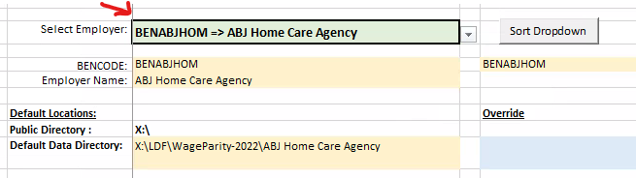

1. On worksheet ‘Client_Input_File’ , click on ‘Get Data’ Button. This will clear the template and Open File Manager

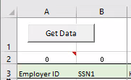

Select the Client Input File.

For example => S:\Work (Public)\LDF\WageParity-2022\ABJ Home Care Agency\ABJ Benefit - C2022 Feb.xlsx

1. When the data has been copied, a message will appear

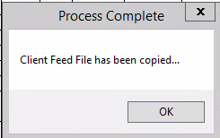

1. Review that the **data** matches the column headers. All headers may not match as indicated by the ‘Count of Headers not matching’ indicator but the data should match the ‘Green’ headers.

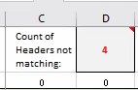

Any unmatched headers will show a “1” in row 2 and highlighted in Red.

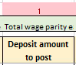

1. On worksheet ‘Demo_Template’, after reviewing the data looks correct, to create the MBI file for IB, click on ‘Create Demo File’ button.

Note: If a file is already created, a message indicating so will appear. Click on ‘Yes’ to replace else ‘No’

1. On worksheet ‘Enroll_Template’, after reviewing the data looks correct, to create the MBI file for IC, click on ‘Create Enroll File’ button.

Note: If a file is already created, a message indicating so will appear. Click on ‘Yes’ to replace else ‘No’

1. On worksheet ‘Deposits_Template’, after reviewing the data looks correct, to create the MBI file for IH, click on ‘Create Deposits File’ button.

Note: If a file is already created, a message indicating so will appear. Click on ‘Yes’ to replace else ‘No’

1. Review the three MBI files that were created and check if correct.

